/20 NAME :
1-Left, Right, Up, Down, Around /5
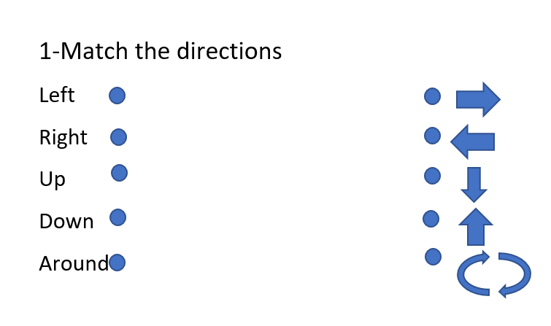
2-Parts of the Body /5 …point =
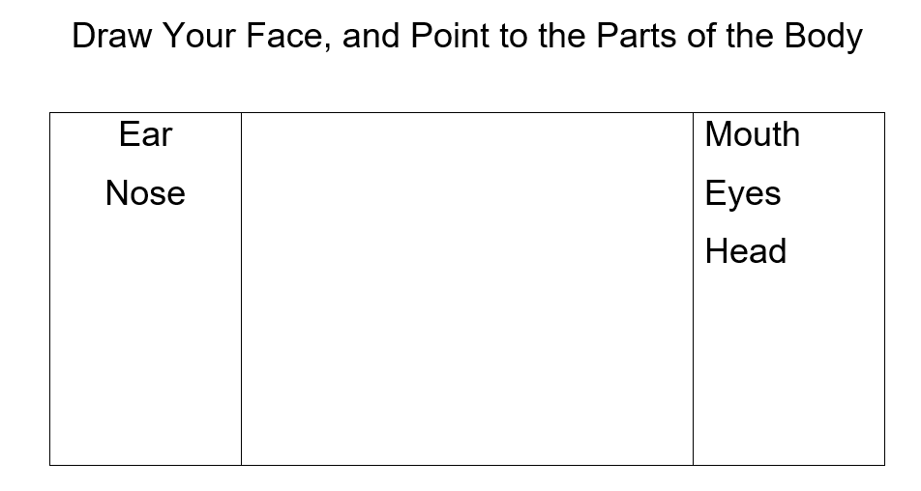
3-Shapes and Colours /10
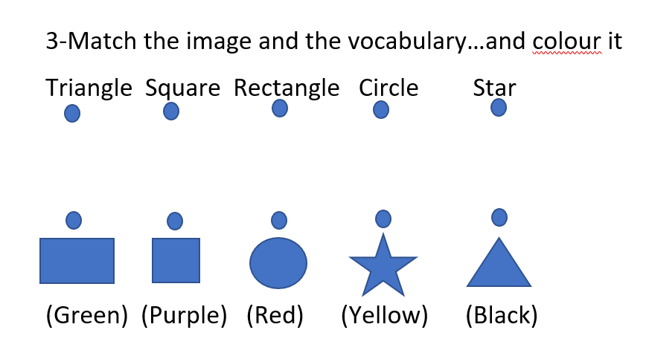
4-Classter
