Name: Group:
/25
Match ( /5)
Breakfast |  | 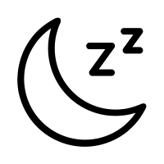
Good Night |  | 
Tell |  | 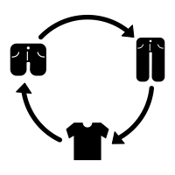
Me |  | 
Get Dressed |  | 

Match ( /5)
See |  | 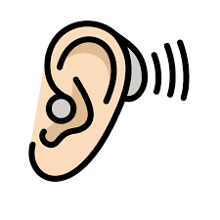
Hear |  | 
Yes |  | 
No |  | 
Think |  | 

Head
Feet
Neck
Knee
Leg
Stomach
Back
Hand
Shoulder
Thighs
( /10)

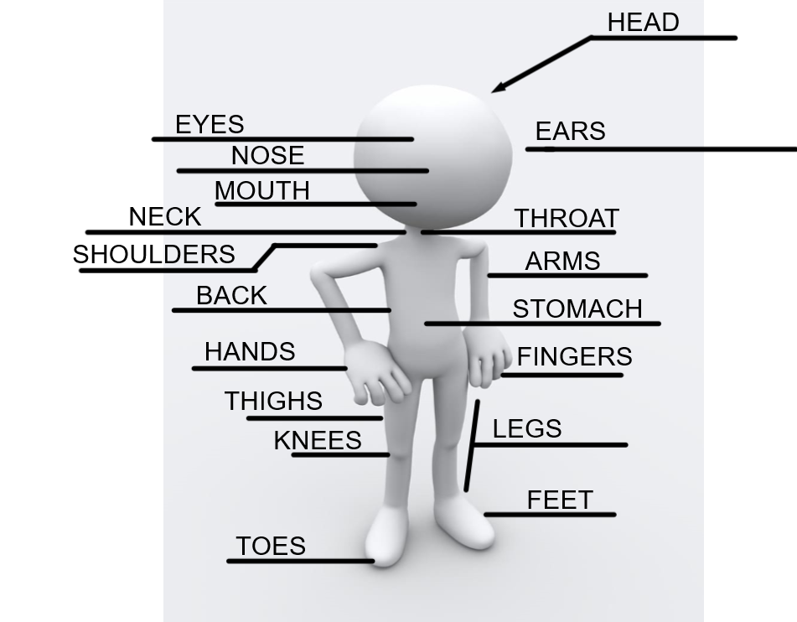
Cl@sster( /5)
I played..I watched..I ate..I went to(1pt)
(the date, 2pts)
Cl@sster

@(invent a name..1 pt)
Draw your weekend (1pt)

