So Far Away

So far away from me
I drove through the desert for days
I’m counting the ways
That I’m passing the days
You’re so far away

You’re so far away from me
I crossed every highway
I drove through the mountains
I’m counting the ways
That I’m passing the days

You’re so far away

Singing…...
So Far Away

So far 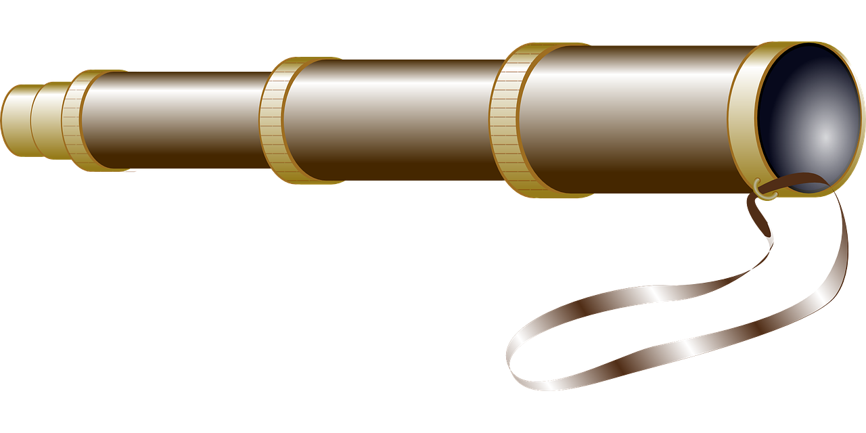away from me 
I drove 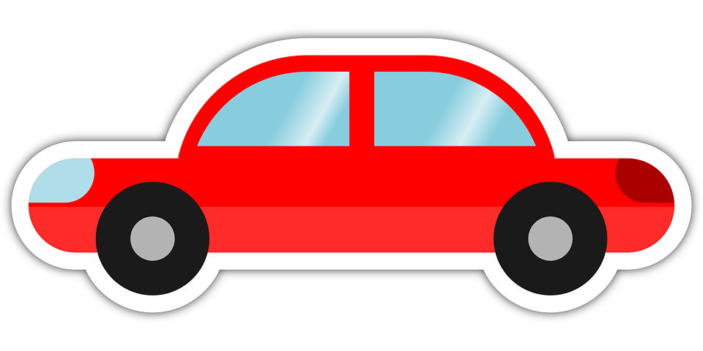through the desert 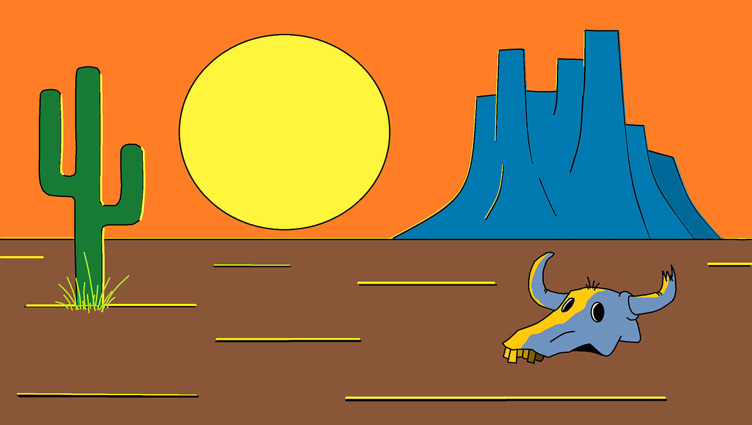for days
I’m counting 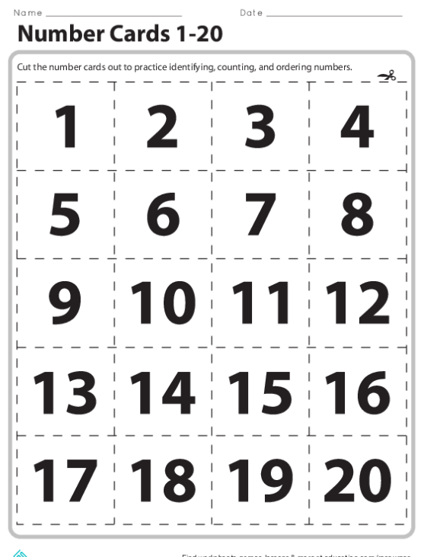the ways
That I’m passing the days
You’re so far away

You’re so far away from me
I crossed every highway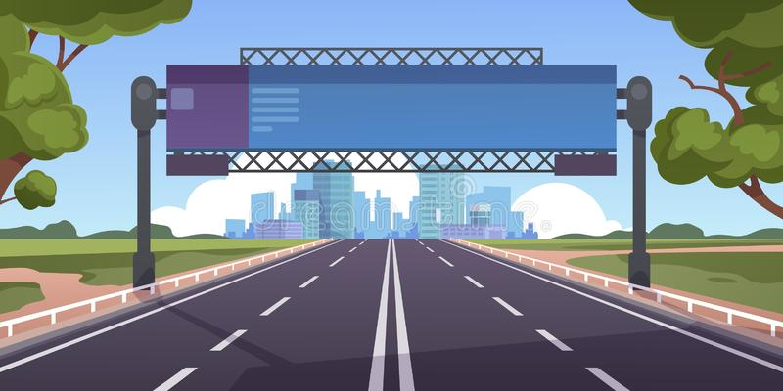
I drove through the mountains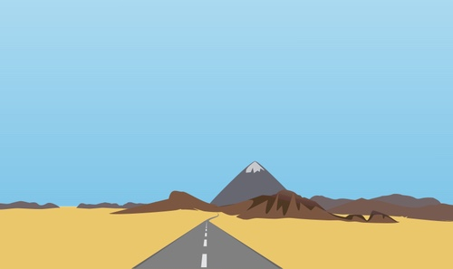
I’m counting the ways
That I’m passing the days

You’re so far away

Singing ...
So Far Away

So far away from me
I drove through the desert for days
I’m counting the ways
That I’m passing the days
You’re so far away

You’re so far away from me
I crossed every highway
I drove through the mountains
I’m counting the ways
That I’m passing the days

You’re so far away…
Singing…...

