Monday

Monday starts the week away
Sometimes I find it hard to get up that day

Tuesday’s on as we move along
And I’m feeling strong as we’re moving on

Wednesday comes, I’m getting so much done
I’m feeling at my peak, the middle of the week

Thursday’s here, I’m gonna start to cheer
It’s becoming clear, the weekend’s getting near

It’s Friday now, I’m gonna tell you how
I’m planning to spend my weekend

Saturday, do things my way
There’s so much to do, will I go or stay?

On Sunday, I try to rest
Monday’s almost here, I wanna be my best.
Monday

Monday 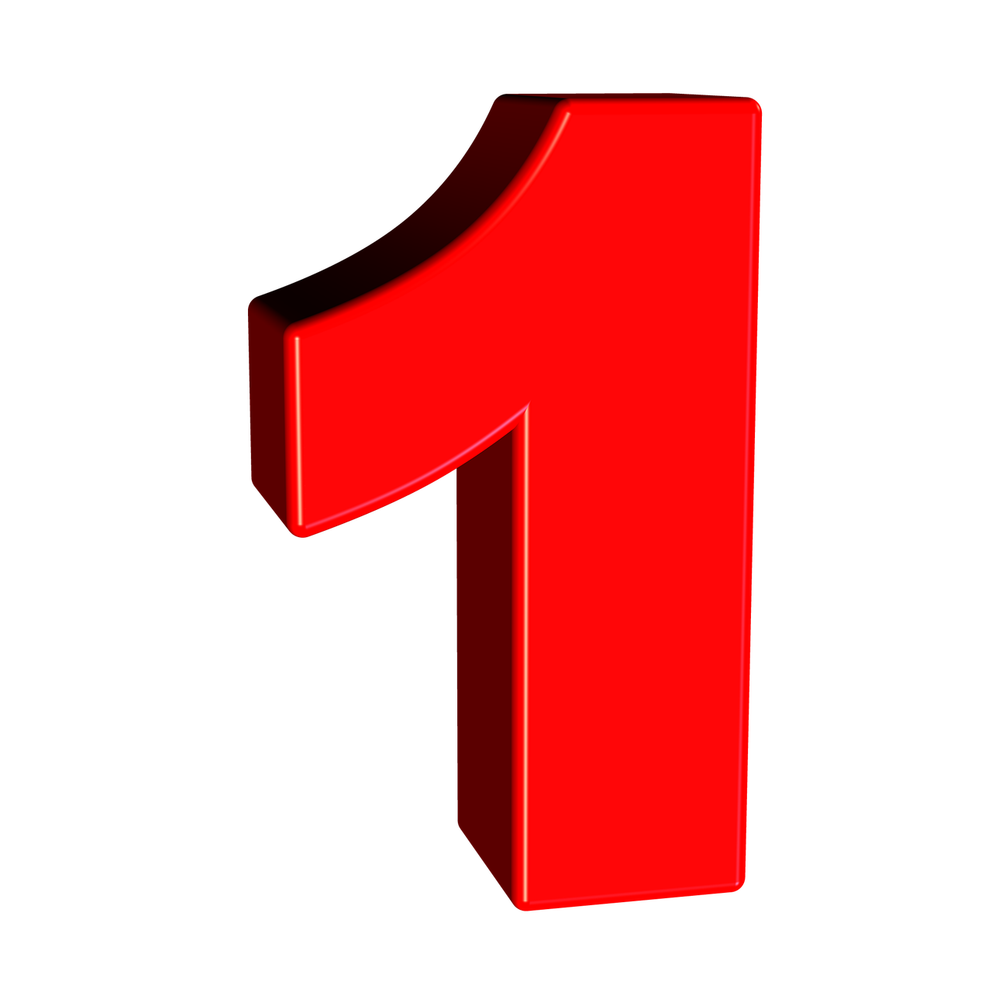starts the week away
Sometimes I find it hard to get up  that day
Tuesday  is on as we move along
And I’m feeling strong 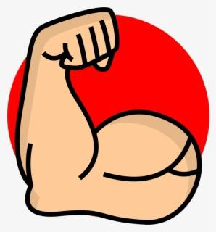 as we’re moving on 
Wednesday 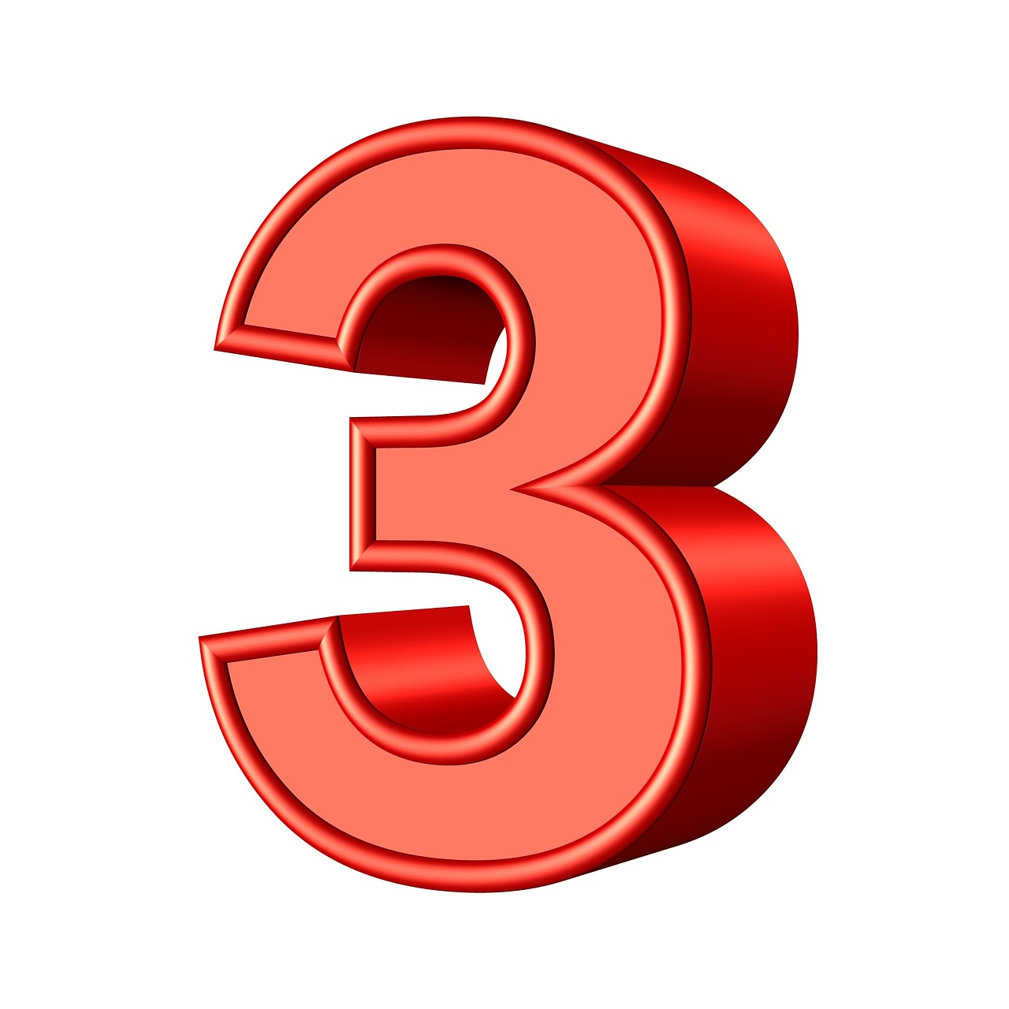comes, I’m getting so much done
I’m feeling at my peak 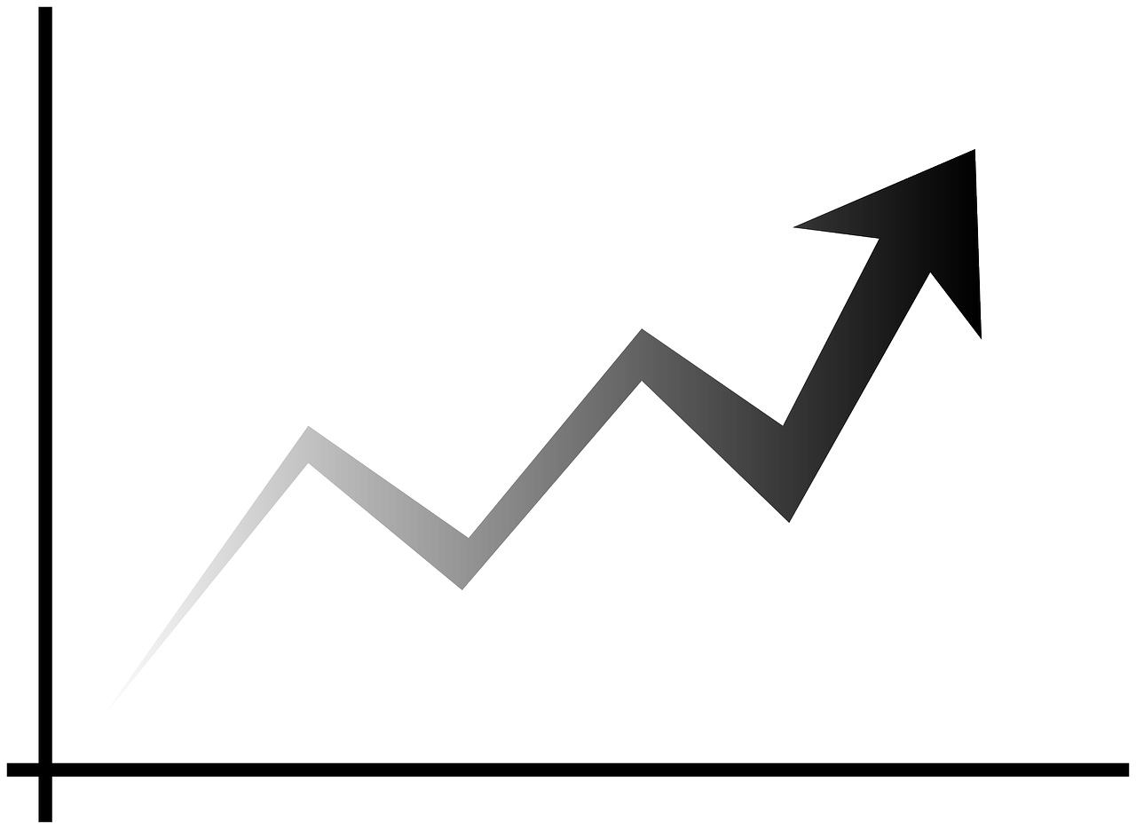, the middle of the week
Thursday 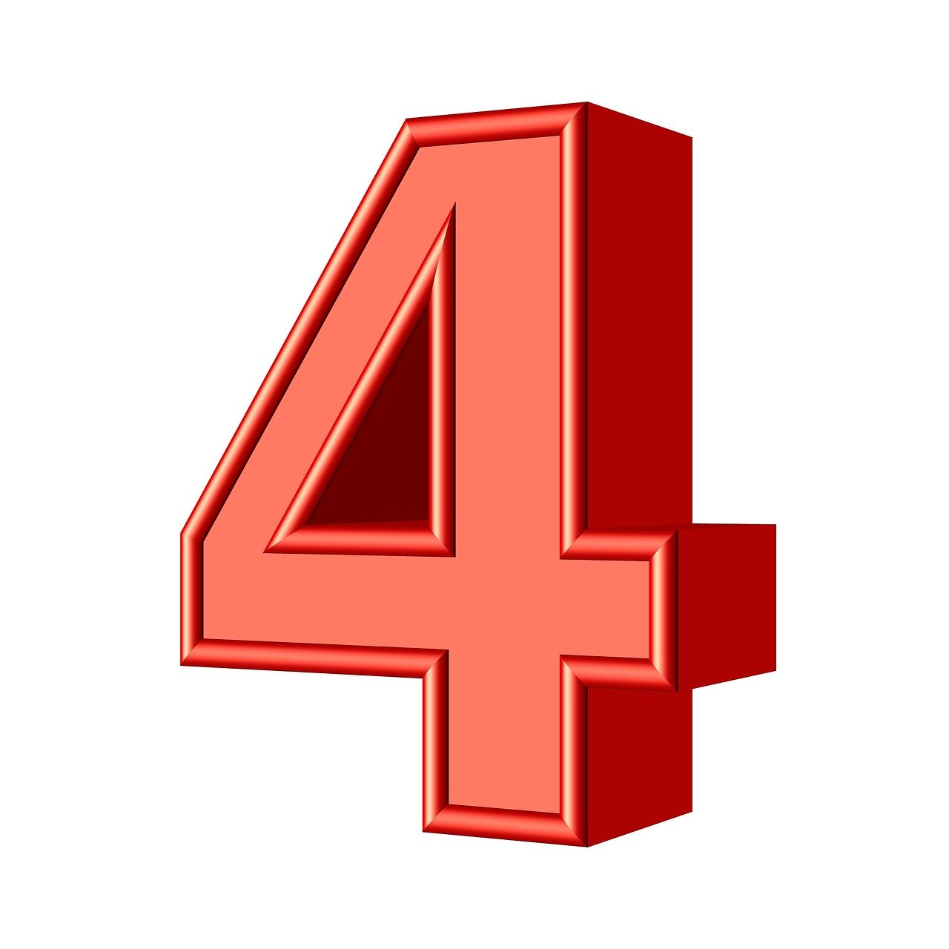 here, I’m gonna start to cheer 
It’s becoming clear, the weekend 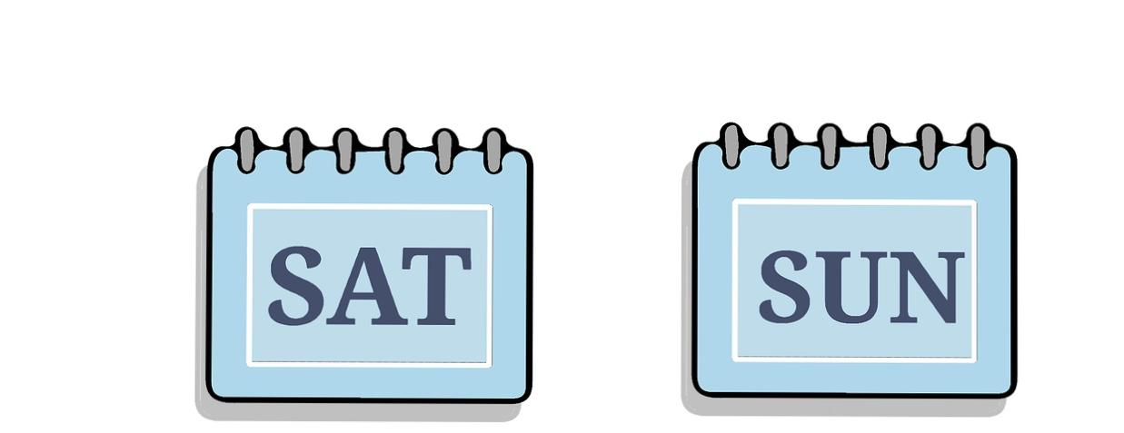 is getting near 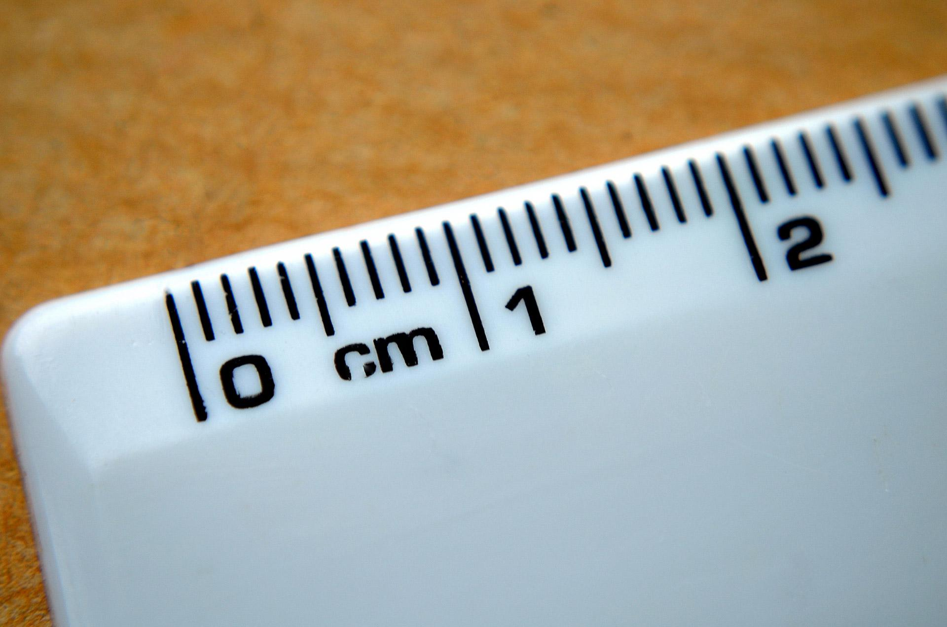
It’s Friday now, I’m gonna tell 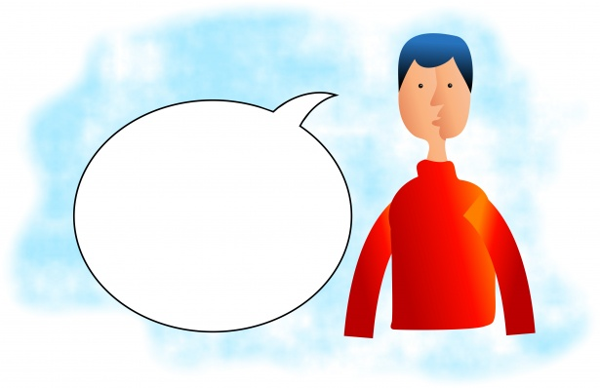you how
I’m planning to spend my weekend

Saturday do things my way
There’s so much to do, will I go 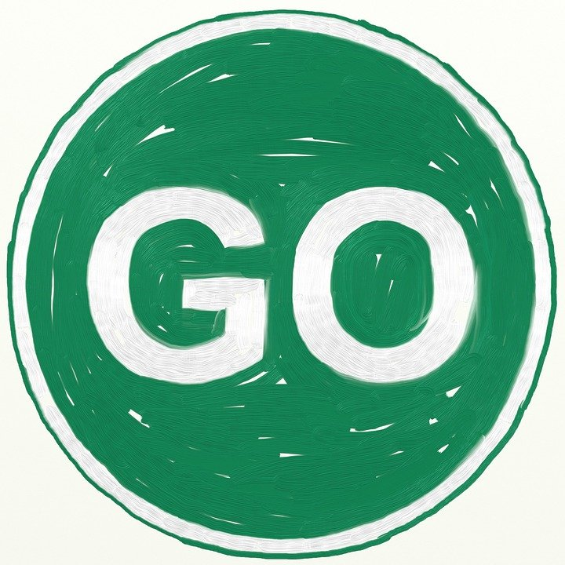 or stay 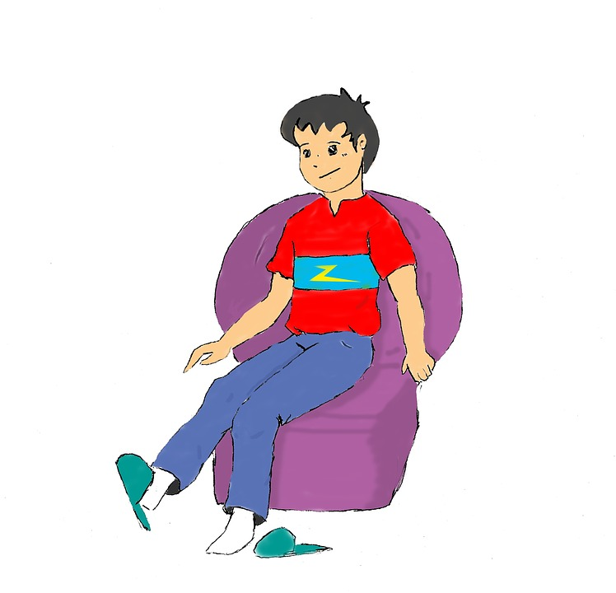?
On Sunday 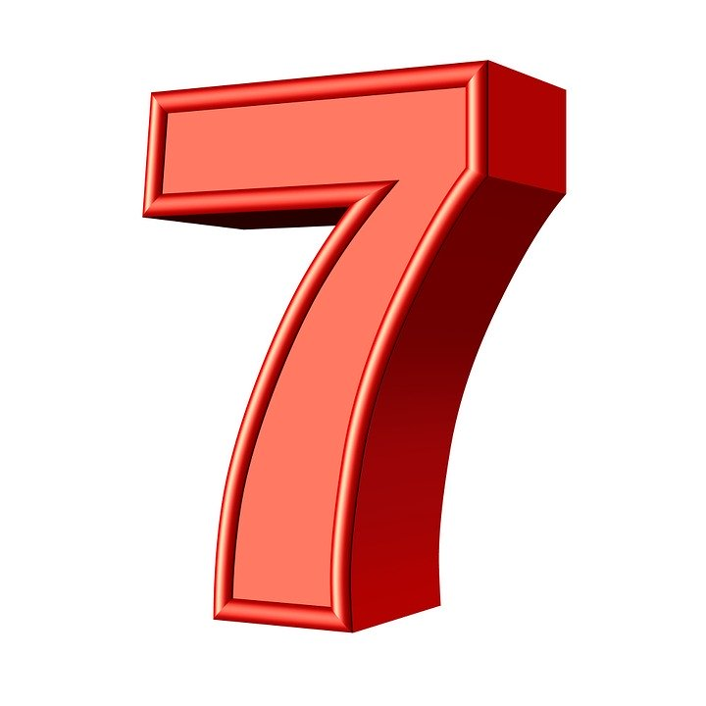 I try to rest 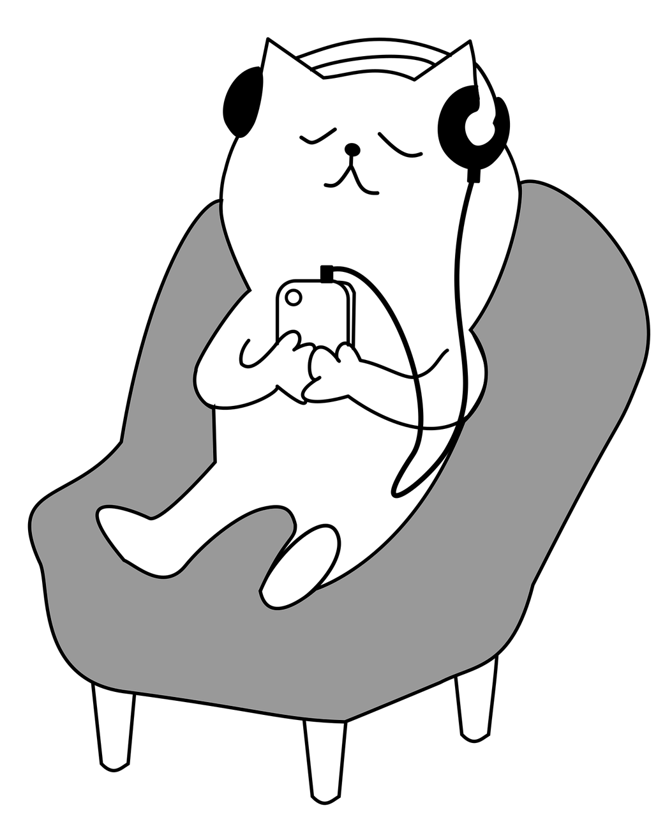
Monday’s almost here, I wanna be my best .

Monday

Monday starts the week away
Sometimes I find it hard to get up that day

Tuesday is on as we move along
And I’m feeling strong as we’re moving on

Wednesday comes, I’m getting so much done
I’m feeling at my peak , the middle of the week

Thursday here, I’m gonna start to cheer
It’s becoming clear, the weekend is getting near

It’s Friday now, I’m gonna tell you how
I’m planning to spend my weekend

Saturday do things my way
There’s so much to do, will I go or stay ?

On Sunday I try to rest
Monday’s almost here, I wanna be my best .

