Getting There
There’s some things that you need to know
When you’ve got some place to go
Don’t you know it doesn’t where
You need to know how you’re getting there

Maybe we could take a boat
Maybe we could take a train
Maybe we could take a car
Maybe we could take a plane

Oh tell me are you in a rush
If not then you can take the bus
If you are then you can grab a cab
It depends how much time you have

Maybe we could take a boat
Maybe we could take a train
Maybe we could take a car
Maybe we could take a plane

Getting There
There’s some things that you  need to know 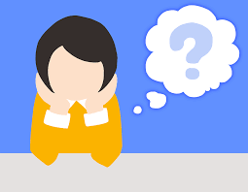
When you’ve got some place to go 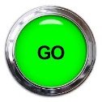 Don’t you know it doesn’t where You need to know how you’re getting there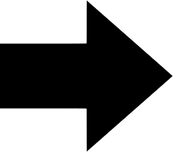

Maybe we could take a boat 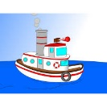 Maybe we could take a train 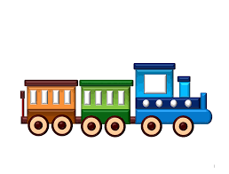 Maybe we could take a car 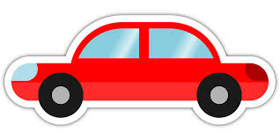
Maybe we could take a plane 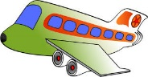

Oh tell me are you in a rush 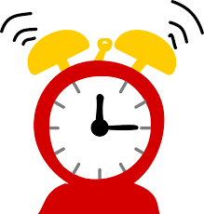 If not then you can take the bus 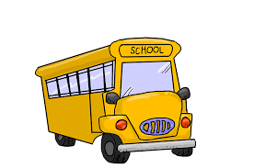If you are then you can grab a cab 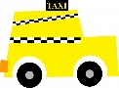
It depends how much time 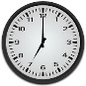 you have

Maybe we could take a boat
Maybe we could take a train
Maybe we could take a car
Maybe we could take a plane

Getting There
There’s some things that you need to know
When you’ve got some place to go
Don’t you know it doesn’t where
You need to know how you’re getting there

Maybe we could take a boat
Maybe we could take a train
Maybe we could take a car
Maybe we could take a plane

Oh tell me are you in a rush
If not then you can take the bus
If you are then you can grab a cab
It depends how much time you have

Maybe we could take a boat
Maybe we could take a train
Maybe we could take a car
Maybe we could take a plane

