Colors

As I look around the world
And I shift my focus to
All the firetrucks that are red
And the seas of the deepest blue
And the sun the brightest yellow
But don't look it's much too bright
Even shining off the winter sun
Lighting up its white

And the greenest green it seems
Can be seen in rolling fields of grass
And the grayest greys make way
In the clouds of storms that pass

And the nights the darkest black
black

The orange of the fire
And the purple of the grape
Pink like cotton candy
And the brown of the leaves we rake

And the night's the darkest black
black

Colors

As I look around the world   And I shift my focus  to  All the firetrucks 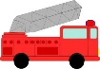 that are red  And the seas 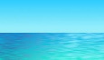 of the deepest blue  And the sun 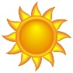 the brightest yellow, but don't look it's much too bright  Even shining off the winter  snow 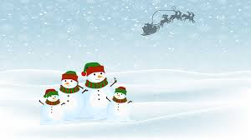 lighting up its white | And the greenest green it seems  can be seen in rolling fields of grass 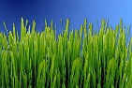  And the grayest greys make way  In the clouds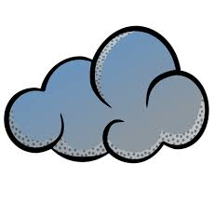 of storms that pass  And the night’s  the darkest black, black  The orange of the fire 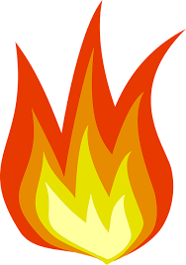  And the purple of the grape 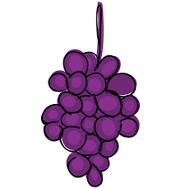  Pink like cotton candy   And the brown of the leaves 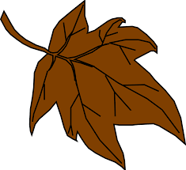we rake  And the night's the darkest black, black

Colors
As I look around the world  And I shift my focus to  All the firetrucks that are red  And the seas of the deepest blue  And the sun the brightest yellow, but don't look it's much too bright  Even shining off the winter  snow lighting up its white |  |  |  | And the greenest green it seems  can be seen in rolling fields of grass  And the grayest greys make way  In the clouds of storms that pass  And the night’s the darkest black, black  The orange of the fire  And the purple of the grape  Pink like cotton candy  And the brown of the leaves we rake  And the night's the darkest black, black
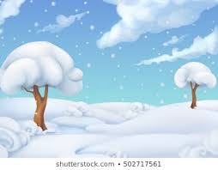 | 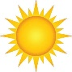 | 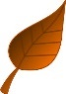 | 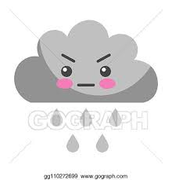 |  | 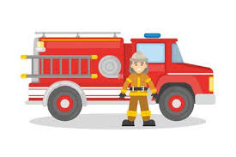 | 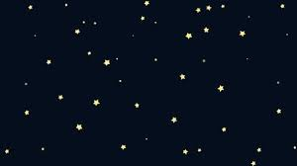 | 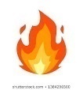
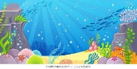 |  |  | 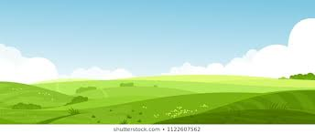 |  | 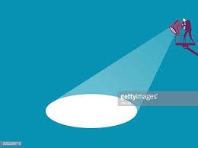 | 